Spring
Warm winds blow and blow,
Leaves hug flowers as they hope,
Green begins to show.
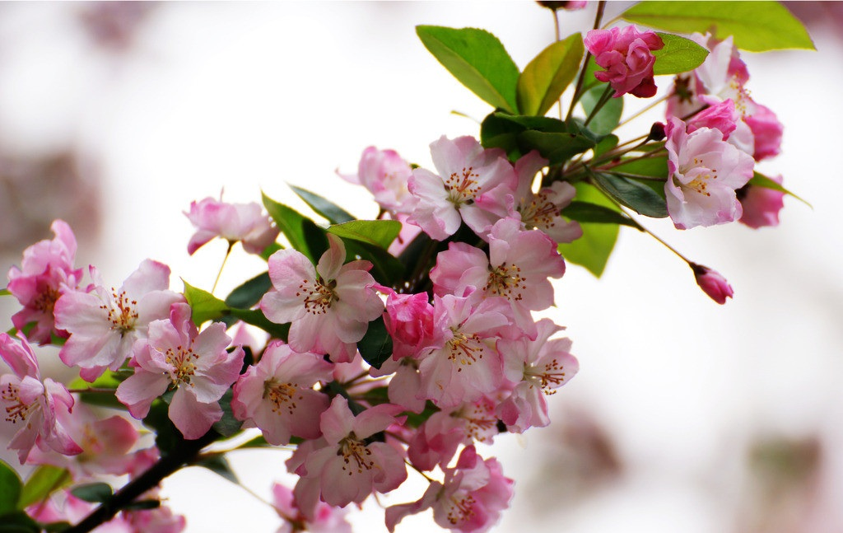
Photo from nipic.com

Summer
Strawberry ice cream,
Take your bathing suit to swim,
Here comes the hot wind.
Photo from nipic.com

Autumn
Red leaves yellow leaves,
Falling down from the old trees,
Blowing as they are free.
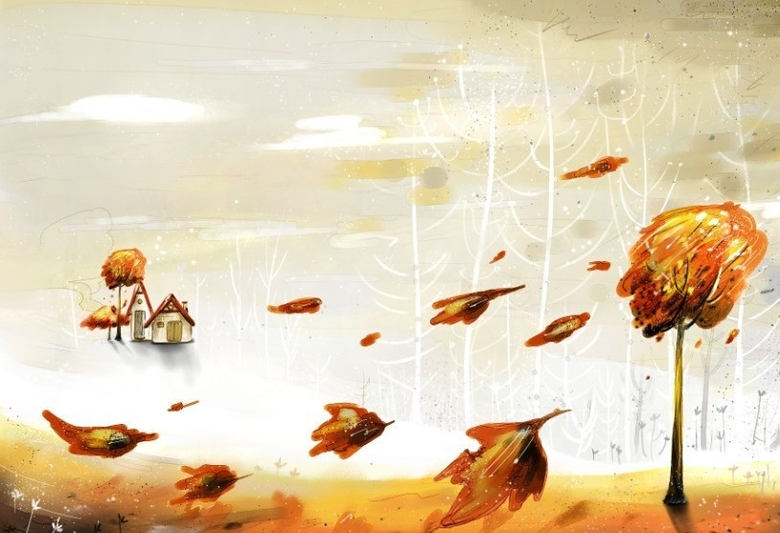
Photo from nipic.com

Winter
Water turns into ice,
In the cold air snowflakes fly,
World is covered white.
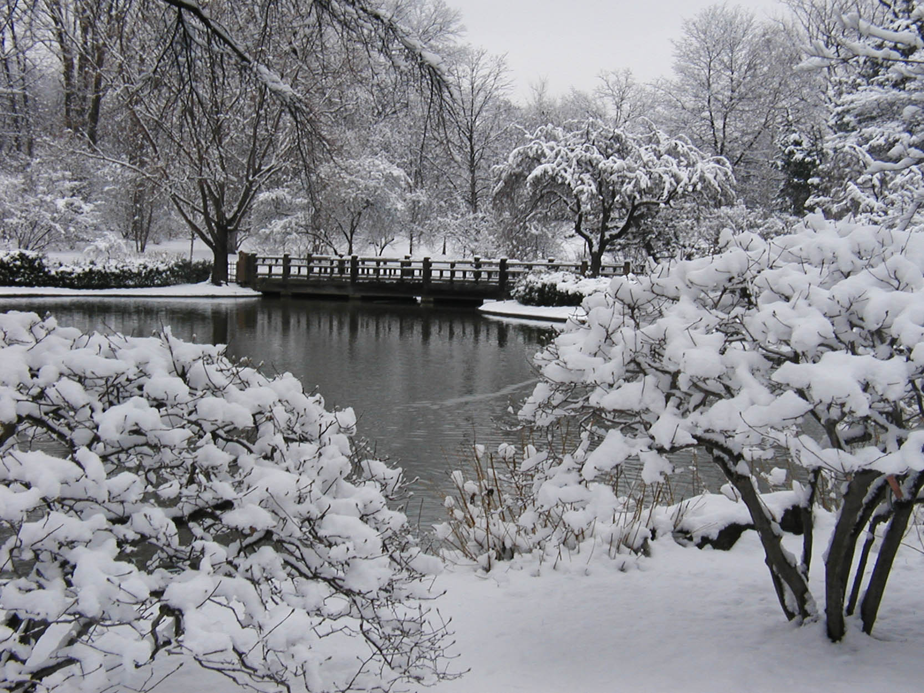
Photo from giantbomb.com

